Chapter 14, Problem 39.

For the “tank” circuit in Fig. 14.79, find the resonant frequency.

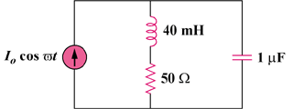

Figure 14.79
For Problems 14.39, 14.71, and 14.91.

